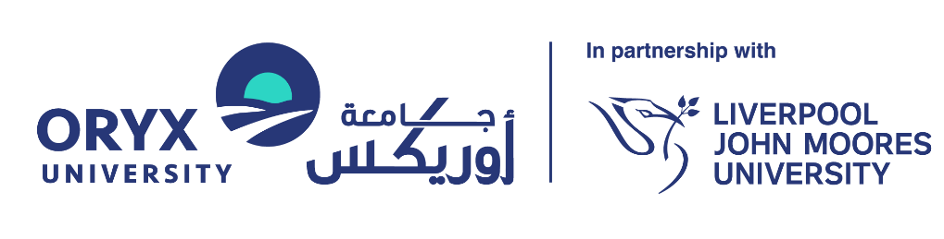

Distinguished Speaker Request Form
ORYX UNIVERSITY
In Partnership with Liverpool John Moores University

Document Reference: | RKEO-FRM-Distinguished Speaker Request
Version: | 1.0
Effective Date: | 14 February 2026
Review Cycle: | Annual
Next Review Date: | 14 February 2027
Document Owner: | Director of Research and Knowledge Exchange
Responsible Office: | Research and Knowledge Exchange Office (RKEO)
Approved By: | University President

Version History
Version | Author | Description of Changes | Date
Version 1.0 | Dr. Maher Salem | Created the first version | 12 Feb 2026

Purpose: To propose and approve invitations for high-profile external speakers, ensuring strategic alignment and proper protocol.

SECTION A: HOST DETAILS
Field | Details
Host Name
Faculty/Department
Proposed Date/Time

SECTION B: SPEAKER PROFILE
Speaker Name:
Current Affiliation/Title:
Bio / Reputation Summary: (Why is this speaker distinguished? e.g., H-index, Industry Leader, Nobel Laureate)

Proposed Topic/Title:

Strategic Value: (How does this visit benefit Oryx University?)

SECTION C: LOGISTICS & PROTOCOL
Target Audience:
[ ] Students
[ ] Faculty
[ ] Public
[ ] VIP/Government
Expected Attendance:
Protocol Requirements:
[ ] Visa Assistance Required
[ ] Media/PR Coverage Requested
[ ] Meeting with President/Senior Leadership Requested

SECTION D: BUDGET
Item | Cost (QAR) | Source
Honorarium (if applicable)
Travel & Accommodation
Hospitality/Catering
TOTAL

SECTION E: APPROVALS
Dean Approval: | Date:
RKEO/PR Review: | Date:

